**RIPv2 Project**

Objectives

In this Capstone Project activity, you will demonstrate your ability to:

* Design, configure, verify, and secure RIPv2 IPv4 on a network
* Design a VLSM addressing scheme for the devices connected to the LANs
* Configure DHCP to assign addressing to 3 LANs
* Configure NAT
* Secure the network through the use of ACLs, switchport-security, and basic security measures.
* Configure VLANs.
* Present your design using network documentation from your Capstone Project network

**Scenario**

You are a network engineer for your small- to medium-sized business. You and your team have been asked to design an IPv4 network that uses the RIPv2 routing protocol. The network consists of four branches that are connected to a headquarters router. The headquarters then connects to an ISP router. Your job is to create a RIPv2-based, VLSM addressed network scheme using IPv4 to accommodate the number of hosts requested for this Capstone Project.

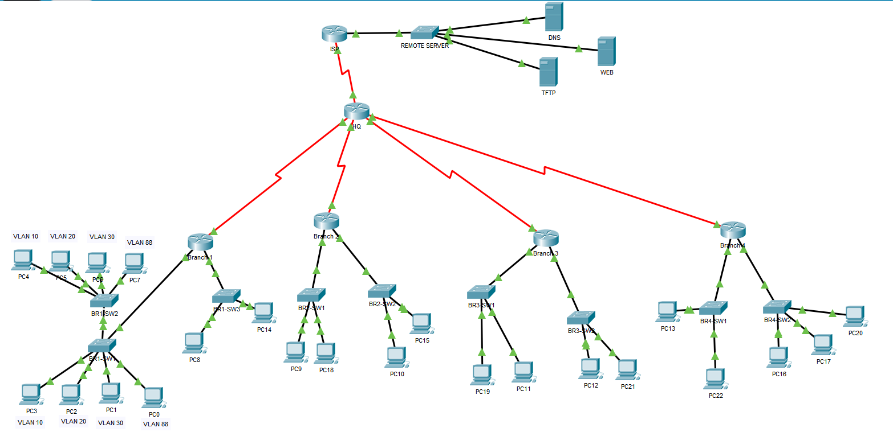

Addressing

|  |  |  |
| --- | --- | --- |
| Host Requirements | Subnet Address | Subnet Mask |
| 500 | 172.25.0.0/ 172.25.1.255 | 255.255.254.0 |
| 500 | 172.25.2.0/ 172.25.3.255 | 255.255.254.0 |
| 200 | 172.25.4.0/ 172.25.4.255 | 255.255.255.0 |
| 120 | 172.25.5.0/ 172.25.5.127 | 255.255.255.128 |
| 80 | 172.25.5.128/ 172.25.5.255 | 255.255.255.128 |
| 80 | 172.25.6.0/ 172.25.6.127 | 255.255.255.128 |
| 60 | 172.25.6.128/ 172.25.6.191 | 255.255.255.192 |
| 30 | 172.25.6.192/ 172.25.6.223 | 255.255.255.224 |
| 4 | 172.25.6.224/ 172.25.6.231 | 255.255.255.252 |
| 4 | 172.25.6.232/ 172.25.6.239 | 255.255.255.252 |
| 4 | 172.25.6.240/ 172.25.6.247 | 255.255.255.252 |
| 4 | 172.25.6.248/ 172.25.6.255 | 255.255.255.252 |

Creating VLANS. Create 4 subnets from one of the 500 networks. One VLAN should be used for the Management VLAN.

|  |  |  |  |
| --- | --- | --- | --- |
| Name and Number | Port Range | Subnet Address | Subnet Mask |
| VLAN 10 HR | f0/2-f0/6 | 172.25.10.1 | 255.255.254.0 |
| VLAN 20 AdminStaff | f0/7-f0/11 | 172.25.20.1 | 255.255.254.0 |
| VLAN 30 CallStaff | f0/12-f0/22 | 172.25.30.1 | 255.255.254.0 |
| VLAN 88 Management | f0/23 | 172.25.88.1 | 255.255.254.0 |
| VLAN 99 Native | N/A | N/A | N/A |
| VLAN 55 BlackHole | Unused Ports | N/A | N/A |

Device Addressing

|  |  |  |  |  |
| --- | --- | --- | --- | --- |
| Device | Interface | Address | Subnet Mask | Default Gateway |
| Branch 1 | g0/0.10  g0/0.20  g0/0.30  g0/0.88  g0/2  s0/2/0 | 172.25.10.1  172.25.20.1  172.25.30.1  172.25.88.1  172.25.2.1  172.25.6.225 | 255.255.254.0  255.255.254.0  255.255.254.0  255.255.254.0  255.255.254.0  255.255.255.252 | 172.25.99.1  172.25.2.2 |
| Branch 2 | G0/0 | 172.25.4.1 | 255.255.255.0 | 172.25.4.2 |
|  | G0/1 | 172.25.5.1 | 255.255.255.128 | 172.25.5.2 |
| Branch 3 | G0/1 | 172.25.5.129 | 255.255.255.128 | 172.25.5.130 |
|  | G0/2 | 172.25.6.1 | 255.255.255.128 | 172.25.6.2 |
| Branch 4 | G0/0 | 172.25.6.129 | 255.255.255.192 | 172.25.6.130 |
|  | G0/1 | 172.25.6.193 | 255.255.255.224 | 172.25.6.194 |
| HQ | S0/0/0 | 209.165.58.65 | 255.255.255.252 |  |
|  | S0/2/0 | 172.25.6.226 | 255.255.255.252 |  |
|  | S0/0/1 | 172.25.6.234 | 255.255.255.252 |  |
|  | S0/3/0 | 172.25.6.242 | 255.255.255.252 |  |
|  | S0/1/1 | 172.25.6.250 | 255.255.255.252 |  |

**SHOW COMMANDS for verifying configuration**

You should have a minimum of 2 show snip-its per item that clearly demonstrate that each element is configured correctly and working as directed. For example, to verify DHCP, you should have snip-its for the show ip dhcp bindings command and show ip dhcp statistics command. The show running-config command is not the best choice for verifying the configuration. Paste the snip-its here.

VLAN configuration

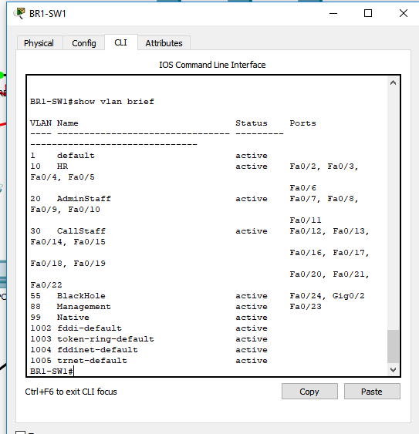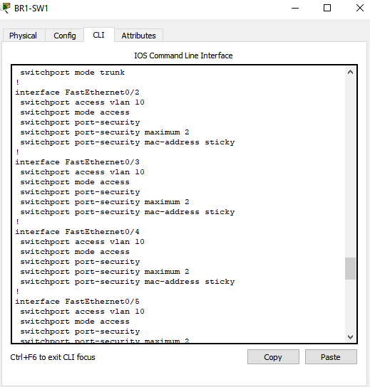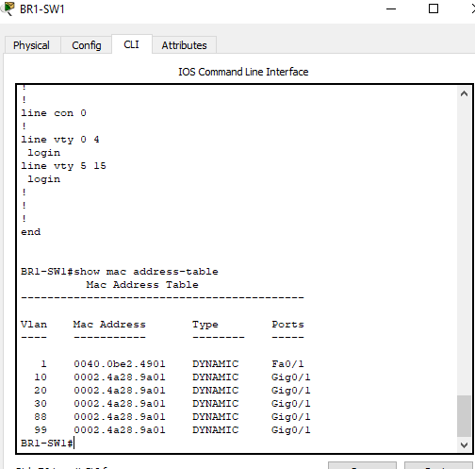

Routing configuration

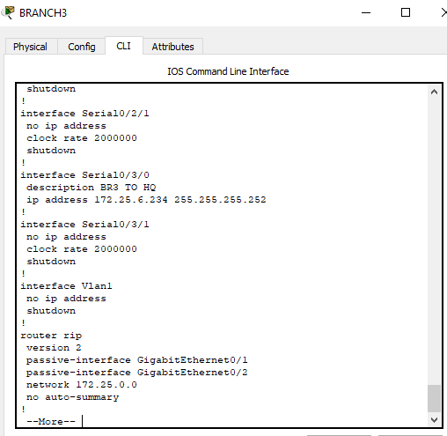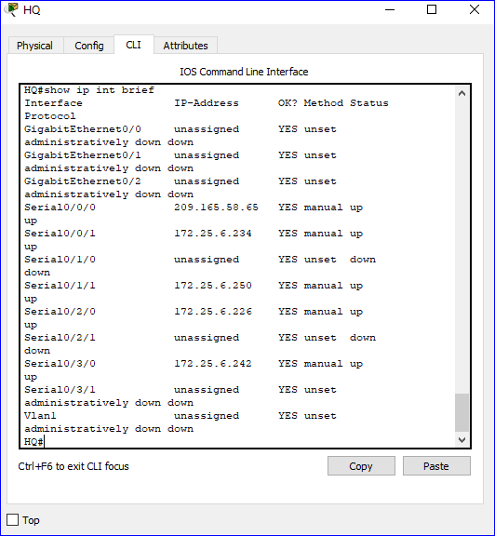

SSH configuration connectivity

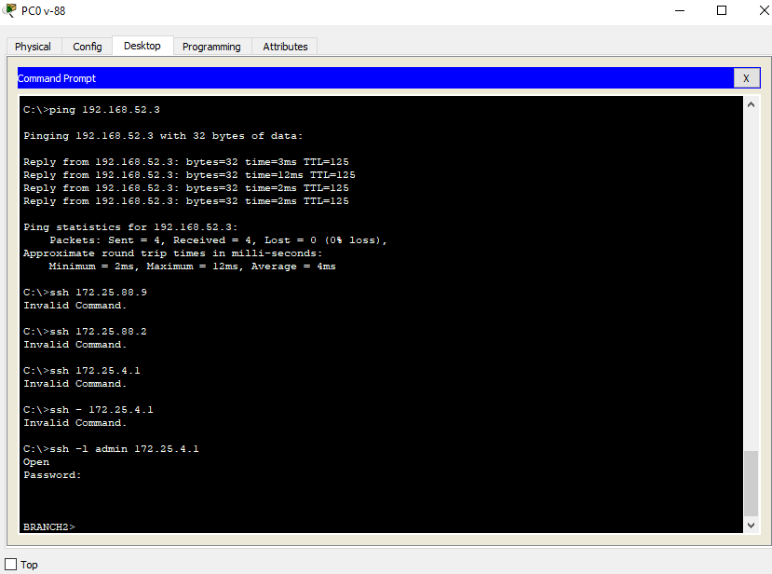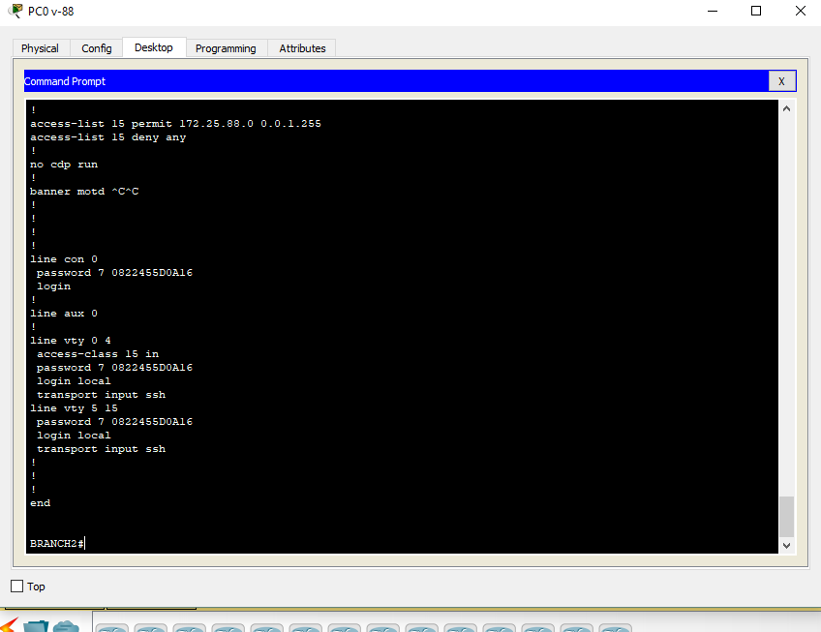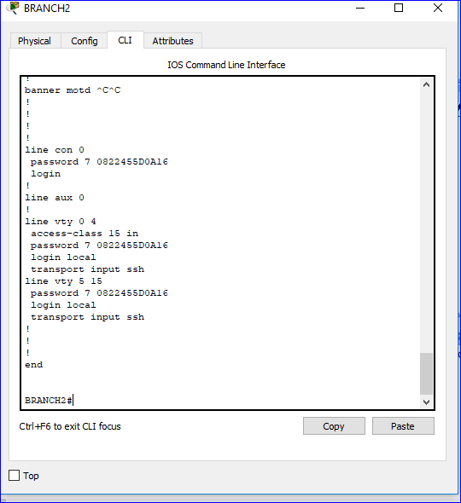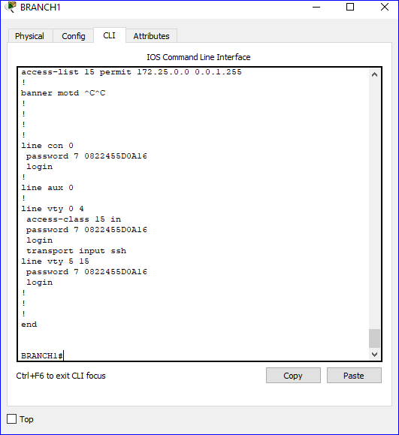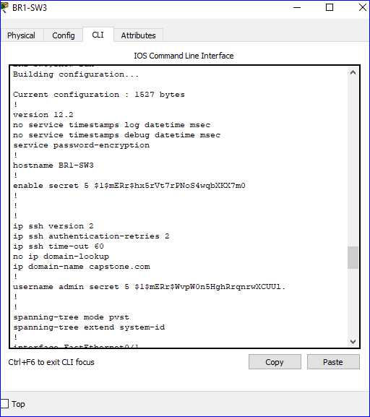

DHCP configuration

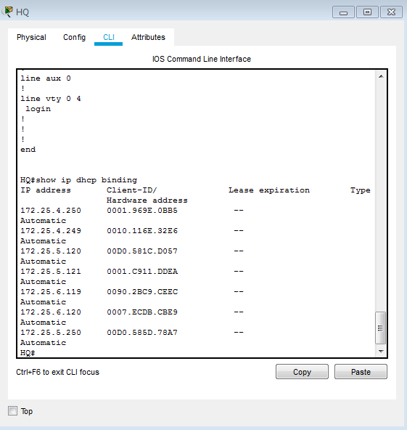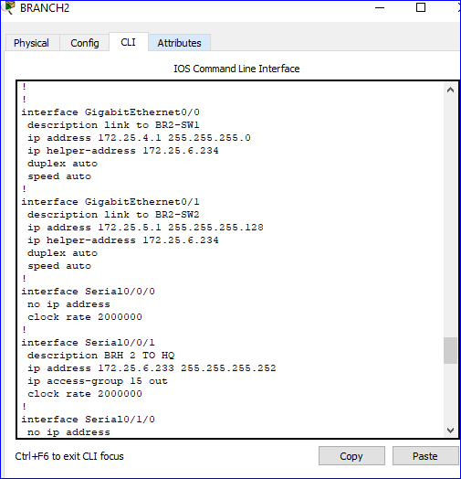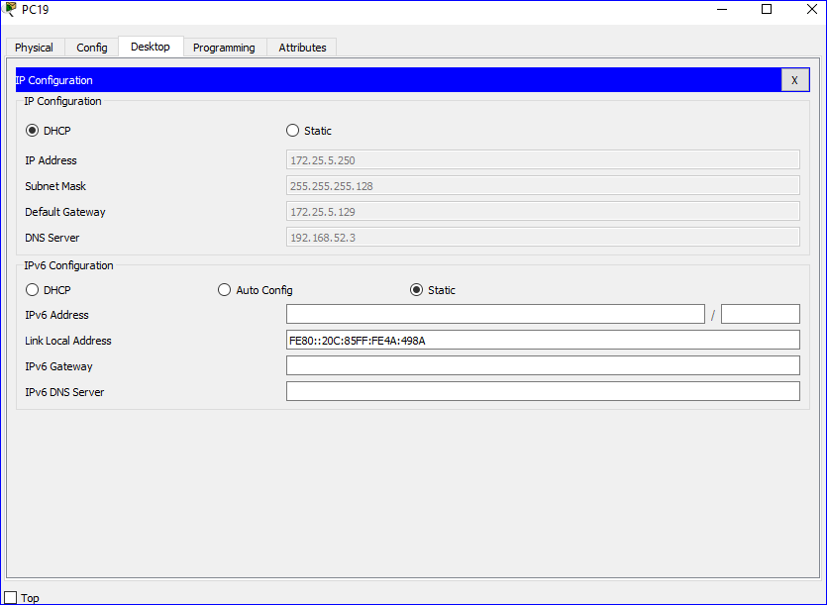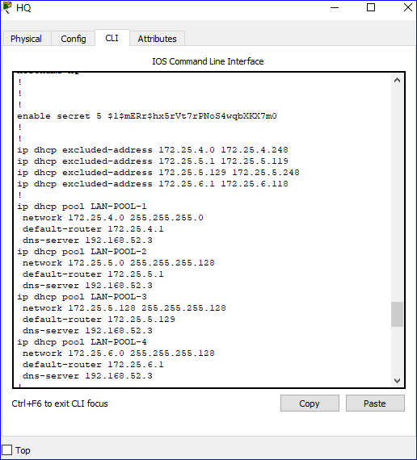

NAT configuration

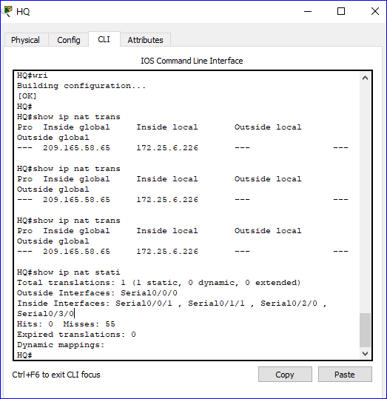

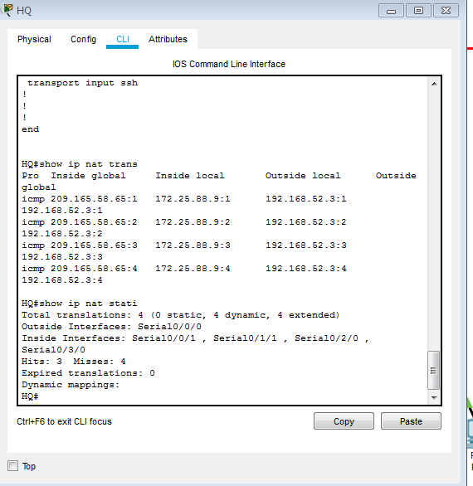

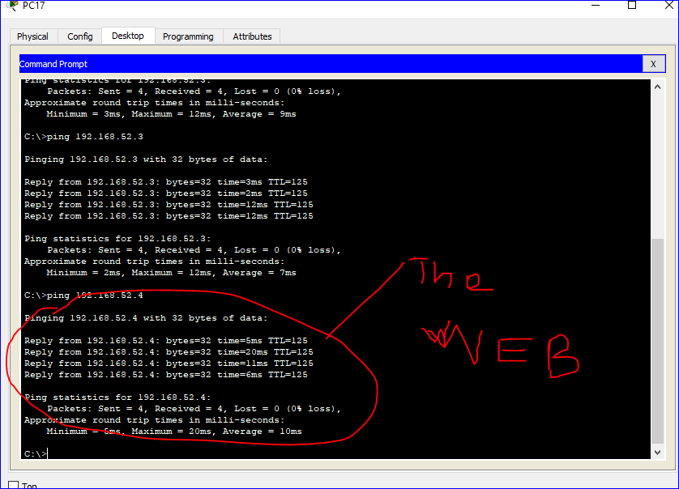

ACL configuration

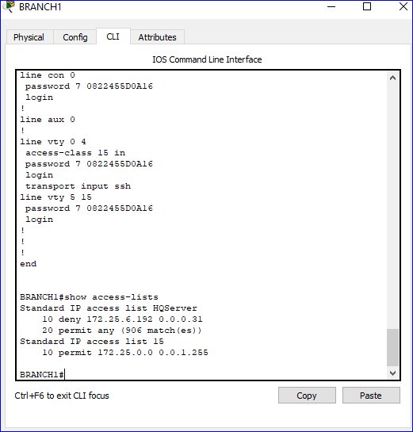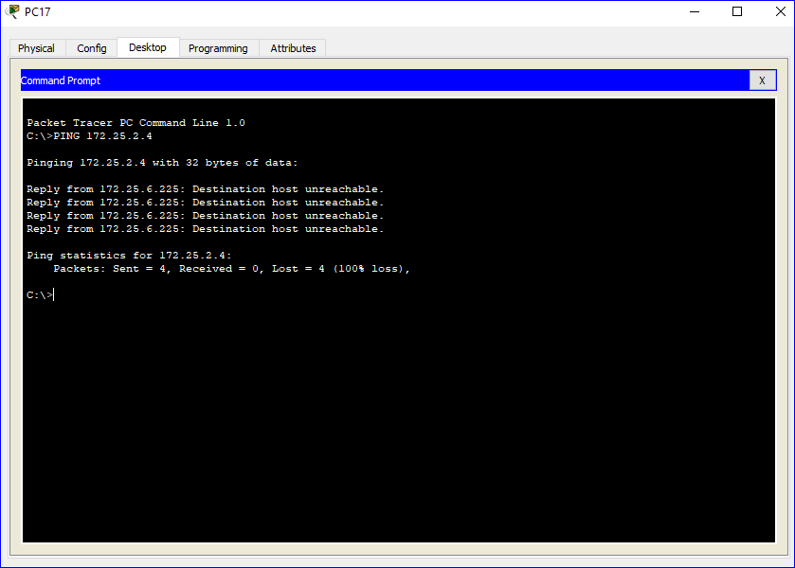

TFTP server configuration

